Missouri Balance of State Continuum of Care Permanent
Supportive Housing Prioritization: Research and Refinement
August 31, 2025 Progress Report
The data science team (DST; led by Dr. Phebe Vayanos) in this project oversees gaining access to, analysis, and understanding the relevance of data from the Missouri Balance of State Continuum of Care Homeless Management Information System (MO BoS CoC HMIS). The data team has been working since the start of the project to conduct descriptive analysis and perform predictive modeling to refine the items of the VI-SPDAT, in conjunction with feedback solicited from the community advisory board (CAB) and support from the community engagement team (CET; led by Drs. Tlapek and Hsu). The HMIS data provided by ICA to the DST includes 4,145 unique individuals experiencing homelessness, collected between November 1, 2015 and June 18, 2024. Although providers across the Missouri Balance of State are currently using the VI-SPDAT 3.0 for Single Adults, the HMIS data provided to the DST comes from data collected using the VI-SPDAT 2.0.
In the past six months, the research team has convened two Community Advisory Board (CAB) meetings with the data team to accomplish the following objectives that will allow the data team to build a predictive model for refining the VI-SPDAT tool: (a) to identify the outcome of interest (i.e., the outcome that a refined VI-SPDAT tool should predict), and (b) to examine the transparency (i.e., simplicity) of the refined VI-SPDAT. Given the constraints of the available data accessible to the research team (i.e., MO BoS CoC HMIS), the community engagement team (led by Drs. Tlapek and Hsu) first addressed the data limitations and facilitated CAB discussions regarding the overarching conceptualization of the outcome that should guide the prioritization of scarce housing resources. CAB members reached consensus that housing resources should be prioritized for individuals who are most vulnerable, that is, those for whom adverse events are likely to occur if without housing interventions.
Building on CAB insights, the data science team subsequently identified four adverse events (i.e., ongoing homelessness, sustained homelessness, literal homelessness, and mortality) captured by the HMIS as potential candidate outcomes. (See Figures 1 – 4 below). Ongoing homelessness (Figure 1) was conceptualized as clients who have repeated interactions with homeless services after entering the coordinated entry system, and was defined as more than one homeless related enrolment (i.e., street outreach, safe haven, emergency shelter, day shelter, transitional housing) in the coordinated entry system within one year after receiving VI-SPDAT assessment. Over 37% of individuals included in the HMIS dataset encounter such adverse events.
Sustained homelessness (Figure 2) was conceptualized as clients who cannot resolve their homelessness after one year entering the coordinated entry system, and was defined as having more than one homeless related enrollment between one year after initial VI-SPDAT assessment and two years after the initial assessment. Only 9.3% of individuals included in the HMIS dataset had encountered such adverse events.
Literal homelessness (Figure 3) was conceptualized as clients who are experiencing street homelessness after entering the system and was defined as at least one street outreach enrollment within one year of initial VI-SPDAT assessment. Approximately 5% individuals met this condition. Finally, mortality (Figure 4) was conceptualized as clients who had died while experiencing homelessness and was defined as individuals with death recorded after VI-SPDAT assessment. Only 0.4% individuals fit such a definition.
Figures 1 – 4 illustrates the four outcome choices, which were also presented in the June 10th CAB meeting. Table 1 showcases community feedback received from CAB members regarding the four outcomes presented in the meeting. The CAB at the end of the meeting reached consensus in prioritizing housing resources to people who experience sustained ongoing homelessness, a combination of sustained homelessness and ongoing homelessness, which includes more individual through a wider timeframe. Based on CAB feedback, the DST proposed a new outcome reflecting sustained ongoing homelessness, i.e., individuals who have homeless-related enrollment within 1.5 years after initial VI-SPDAT assessment. In the August CAB meeting, the DST shared this new outcome with the CAB. The cut point of 1.5 years was chosen as it is the longest horizon that allows good accuracy, and the CAB agreed.
With an outcome established, the DST conducted various predictive modeling to establish a parsimonious refined VI-SPDAT (i.e., a refined VI-SPDAT with less items but maintain performance). The derivation for a more parsimonious VI-SPDAT using HMIS data is to address CAB concerns in terms of the length of the current version of VI-SPDAT: CAB members and others across the Balance of State have reported that it may take too much time for individuals experiencing homelessness to complete the full VI-SPDAT with 27 items. Furthermore, a VI-SPDAT tool with fewer items also may reduce the chance of retraumatizing clients via multiple questions asking them to discuss difficult life experiences. Throughout the process of predictive modeling, the DST also tested various scoring systems (e.g., true value vs. integer vs. black box) and shared these options with the CAB members in the August meeting. The selection of a scoring system may impact the simplicity of the tool (i.e., level of difficulty for providers to carry out the tool), and there is a trade off with the accuracy in predicting the outcome. Figure 5. illustrates such a tradeoff based on various scoring systems.
Figures 6. and 7. demonstrate the performance (i.e., accuracy) of real value and integer scoring systems based on number of selected items. For example, in Figure 6., a 10-item refined VI-SPDAT adopting a non-negative real value scoring system can achieve a similar performance compared to a 12-item refined VI-SPDAT using the same scoring system (both with AUC=0.65); however lower than VI-SPDAT refined to allow negative real value scoring (i.e., the blue line) and the black box scoring system (i.e., the red dot). Similarly, Figure 7. illustrates that a 12-item VI-SPDAT adopting a non-negative integer scoring system can achieve satisfactory performance (AUC=0.63). Tables 2 and 3 demonstrate the items which would be included in the refined 10-item non-negative real value scoring VI-SPDAT (Table 2) and the 12-time non-negative integer scoring VI-SPDAT (Table 3). In the August CAB meeting discussions were focused on which scoring system the CAB would prefer, taking performance trade-offs into consideration, identifying any critical items are missing, and noting any items the CAB would prefer to have removed.
Overall, CAB members expressed interest in using AI/ML to support housing allocation and were excited to see that the items identified by AI/ML were actually the ones they considered less traumatizing for individuals experiencing homelessness taking the VI-SPDAT. However, CAB members also cautioned about potential fairness concerns when allocating housing resources using such an AI tool. These fairness concerns will be addressed in the next CAB meeting. In terms of simplicity and accuracy trade-offs, CAB members concurred that fewer items included in the refined VI-SPDAT may be preferable, as long as too much accuracy is not sacrificed. Most members considered 10–12 questions to be a sweet spot for balancing simplicity and accuracy. CAB members also expressed a preference for a true-value scoring system, as in practice providers can enter client responses into computers, which makes calculating the sum score of the refined true-value-based VI-SPDAT feasible. However, a sizable number of CAB members also expressed a preference for an integer scoring system. Further confirmation will be conducted in the next CAB meeting. Finally, CAB members suggested adding items regarding demographics, transportation (currently not included in the original VI-SPDAT), and mental health and disability, while removing items regarding incarceration (item #4 in the original VI-SPDAT) and help-seeking when not feeling well (item #19 in the original VI-SPDAT). Whether and how those modifications may impact predictive accuracy will be examined and discussed in the next CAB meeting.

Figure 1. Ongoing Homelessness
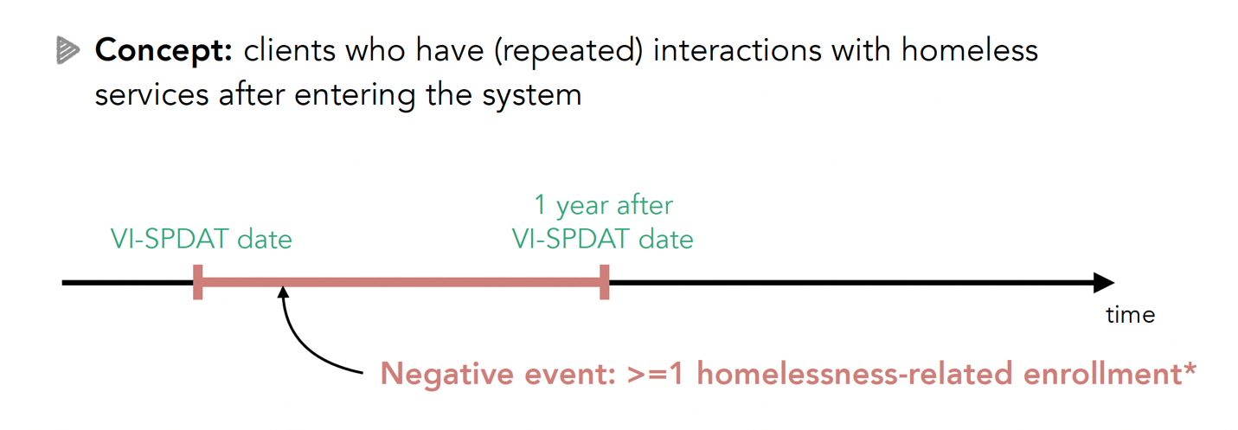

Figure 2. Sustained Homelessness
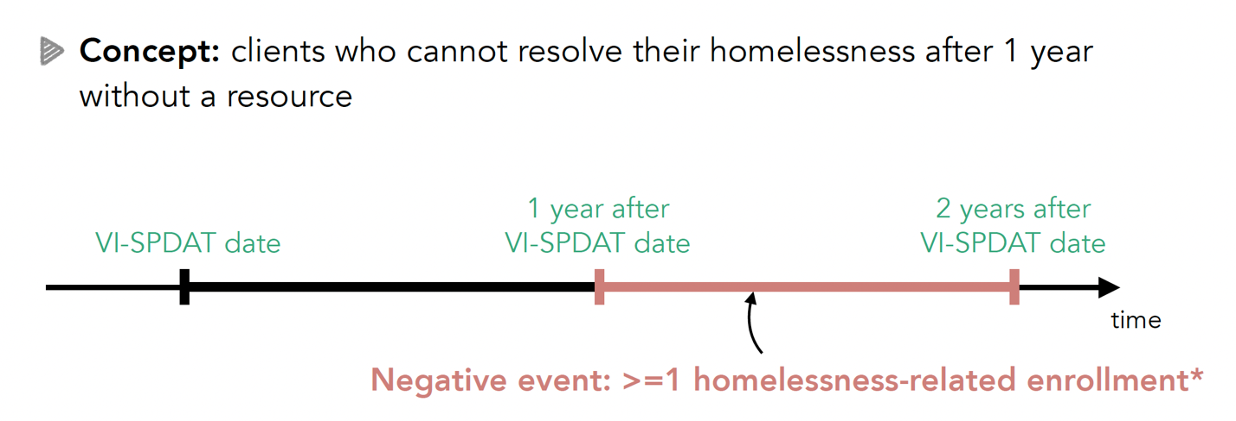

Figure 3. Literal Homelessness
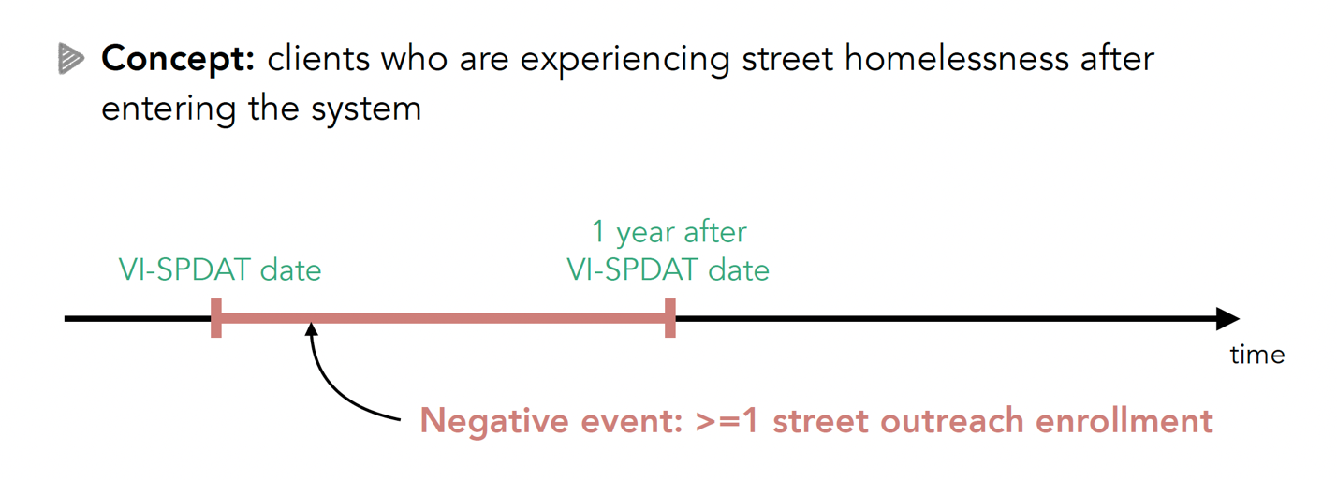

Figure 4. Mortality
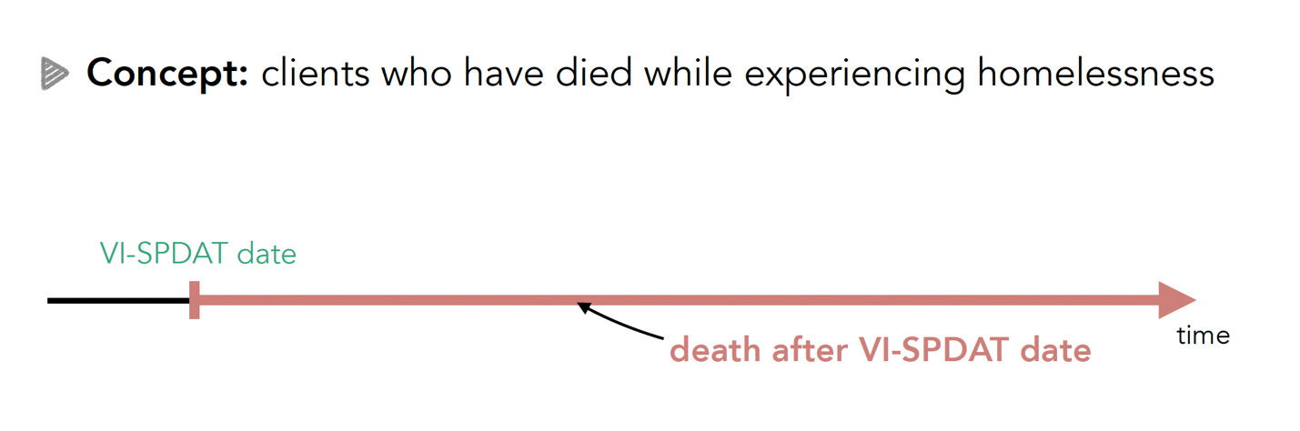

Table 1. CAB Expressed Pros and Cons of the Outcome Choices
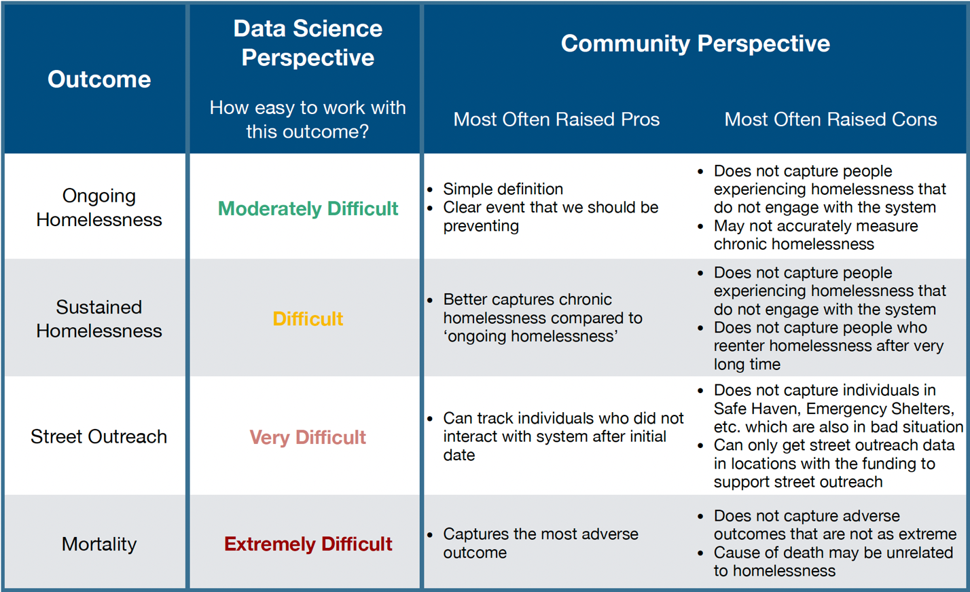

Figure 5. Accuracy and Simplicity Trade-off
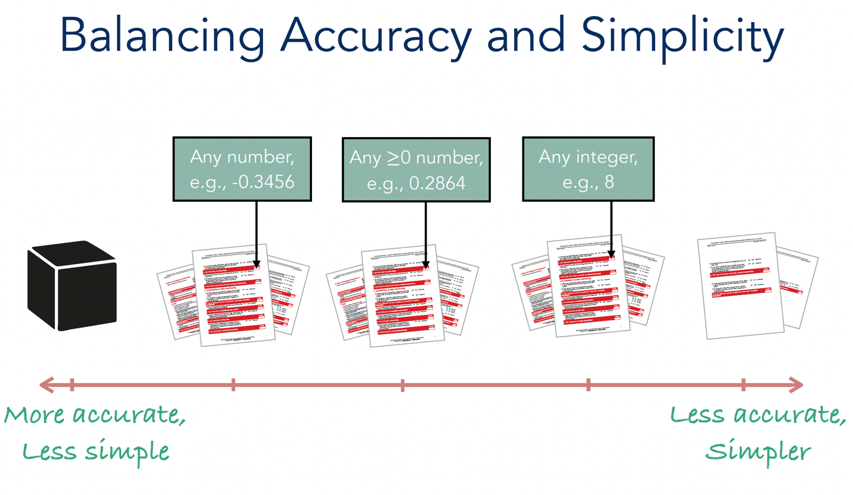

Figure 6. Refined VI-SPDATs with Real Value Scoring System Performance Comparison
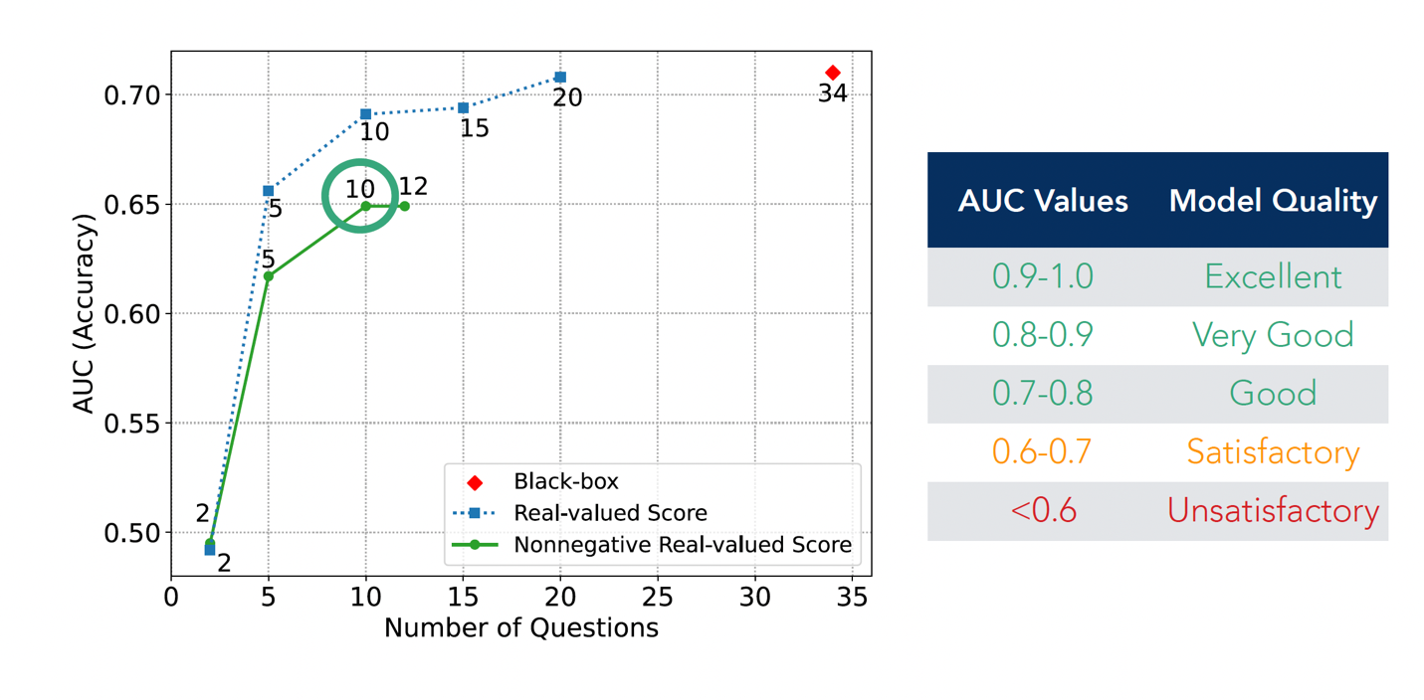

Figure 7. Refined VI-SPDATs with Integer Scoring System Performance Comparison
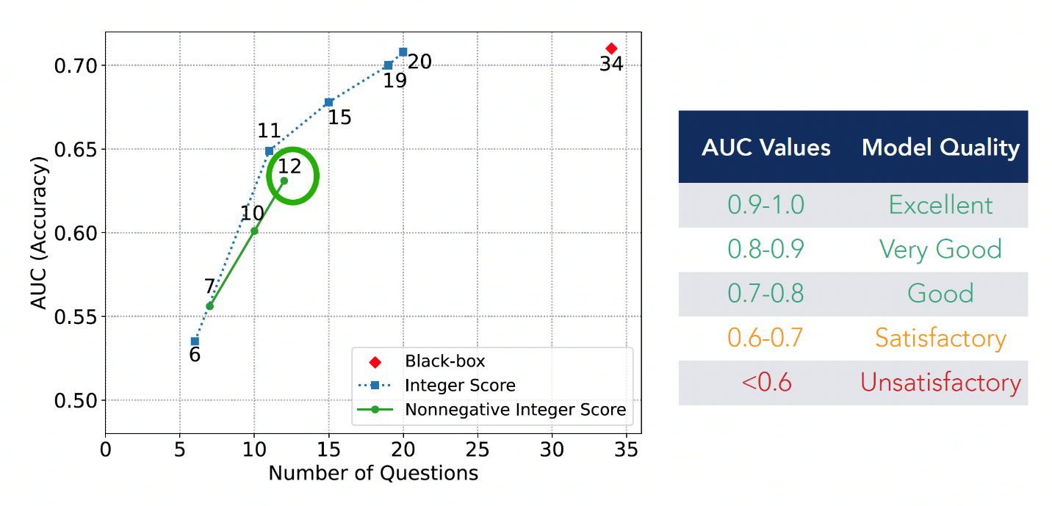

Table 2. Items Included in the 10-Item Non-Negative Real Scoring System VI-SPDAT
Original VI-SPDAT Item Number | Question | Non-Negative Real Value Score
13 | Are you currently able to take care of basic needs like bathing, changing  clothes, using a restroom, getting food and clean water and other things like that? | 0.884
17 | If there was space available in a program that speciﬁcally assists people that  live with HIV or AIDS, would that be of interest to you? | 0.660
4f | In the past six months, how many times have you stayed one or more nights in a holding cell, jail, or prison, whether that was a short-term stay like the drunk tank, a longer stay for a more serious oﬀense, or anything in between? (Add score if at least once) | 0.357
10 | Is there any person, past landlord, business, bookie, dealer, or government  group like the IRS, that thinks you owe them money? | 0.379
22 | Will drinking or drug use make it diﬃcult for you to stay housed or aﬀord your  housing? | 0.324
21 | Has your drinking or drug use led you to being kicked out of an apartment or  program where you were staying in the past? | 0.312
2 | How long has it been since you lived in permanent stable housing? (Add score  if at least 1 year) | 0.291
4 | In the past six months, how many times have you been hospitalized as an  inpatient? (Add score if at least once) | 0.257
12 | Do you have planned activities, other than just surviving, that make you feel  happy and fulﬁlled? | 0.154
19 | When you are sick or not feeling well, do you avoid getting help? | 0.148

Table 3. Items Included in the 12-Item Non-Negative Integer Scoring System VI-SPDAT
Original VI-SPDAT Item Number | Question | Non-Negative Real Value Score
13 | Are you currently able to take care of basic needs like bathing, changing  clothes, using a restroom, getting food and clean water and other things like that? | 9
17 | If there was space available in a program that speciﬁcally assists people that  live with HIV or AIDS, would that be of interest to you? | 7
4f | In the past six months, how many times have you stayed one or more nights in a holding cell, jail, or prison, whether that was a short-term stay like the drunk tank, a longer stay for a more serious oﬀense, or anything in between? (Add score if at least once) | 4
10 | Is there any person, past landlord, business, bookie, dealer, or government  group like the IRS, that thinks you owe them money? | 4
22 | Will drinking or drug use make it diﬃcult for you to stay housed or aﬀord your  housing? | 3
21 | Has your drinking or drug use led you to being kicked out of an apartment or  program where you were staying in the past? | 3
2 | How long has it been since you lived in permanent stable housing? (Add score  if at least 1 year) | 3
4 | In the past six months, how many times have you been hospitalized as an  inpatient? (Add score if at least once) | 2
12 | Do you have planned activities, other than just surviving, that make you feel  happy and fulﬁlled? | 2
4b | In the past six months, how many times have you been taken an ambulance  to the hospital? (Add score if at least once) | 1
 | In the last three years, how many times have you been homeless? (Add score if  at least once) | 1
19 | When you are sick or not feeling well, do you avoid getting help? | 1

