**Missouri Balance of State Continuum of Care - MO 606**

**Request for Proposals for Collaborative Applicant**

**Introduction**

The Continuum of Care (CoC) Program is authorized by subtitle C of title IV of the McKinney-Vento Homeless Assistance Act (42 U.S. C. 11381-11389). The CoC is designed to address the critical problem of homelessness through a coordinated community-based process of identifying needs and building a system of housing and services to address those needs. The CoC Membership designates the Collaborative Applicant. This is done through a process led by the CoC Governance Board and voted upon by CoC members. The CoC Governance Board (Board), after membership approval, designates a Collaborative Applicant to manage the required HUD processes on its behalf to ensure the maximum amount of funds are received by the CoC planning area and that the CoC is in compliance with all applicable HUD rules and regulations.

**Request for Proposals**

The Missouri Balance of State Continuum of Care Board (referenced as MO-606 or the Board) is soliciting proposals for the role of CoC Collaborative Applicant for 2025 – 2028, contingent upon successful annual evaluation and availability of funds. The Transition Team of the Board will receive the applications, review, and then provide the top three proposals to the full MO BoS CoC Board for review. The Board will make a final recommendation to the CoC membership for final approval.

**General Description**

The Collaborative Applicant (CA) is responsible for four (4) main regulatory functions:

1. NOFO Competition

2. Gaps Analysis

3. Point in Time Count

4. Monitoring of CoC grants

MO-606 is contracting for a CA to serve as a fiscal agent. The Scope of Work, detailed in Attachment 1, lists the specific duties of this request for proposal.

**Eligibility**

• Applicants must be an active 501(c) (3) and provide the agency’s determination letter from the IRS, or a governmental entity with the capacity to handle the scope of work (See Attachment I).

• Certification that the Applicant has not been debarred or suspended from receiving federal contracts or grants; and, that there are no outstanding civil judgements against the agency, federal or state.

• Applicants must demonstrate a strong fiscal accounting system and the ability to carry CoC funds for up to 120 days prior to reimbursement.

• Applicants must include the agency’s most recent 990 and the prior two-years of OMB-133 single audit or independent audit reports.

• Applicants must agree to contracting services, as directed by the Board, for NOFO consulting, gaps analysis, PIT, and any other service deemed necessary by the MO BoS CoC Board of Directors.

• Applicants receiving CoC funds, either directly or as a sub-recipient, are eligible to apply as the Collaborative Applicant. Because of the inherent conflict of interest, interested applicants will have an additional section of questions to answer that pertain to avoidance of Conflict of Interest.

**CoC Collaborative Applicant Proposal Requirements**

Applicants are required to follow the sections below in submitting the narrative portion of the application. Applicants must address each request for information under each section. The project award period will be May 1, 2025 to December 31, 2028, pending available funds.

**Agency Capacity (1-page minimum requirement, 4 pages maximum)**

In narrative form, describe the applicant’s capacity to administer the requirements of the MO BoS CoC Collaborative Applicant. This section is intended to allow the applicant agency the opportunity to describe their agency, personnel experience, fiscal responsibility and accounting software, and history with grant administration, CoC activities, and community engagement practices.

a) ability to provide financial staffing oversight to planning grant funds; please include experience of staff responsible for oversight;

b) experience with state and federal grant management and reporting; Please list which state and federal grants the agency has received and managed in the past 5 years;

c) experience, knowledge and participation with Continua of Care and HUD Housing programs;

d) experience with audits and contracts for highly regulated grants;

e) experience, knowledge and participation in Continuum of Care governance; and,

f) please describe your accounting software and types of reports the agency can produce for the CoC Board.

g) Please describe the experience of personnel with federal accounting and their familiarity with CoC grants, if any

**Agency Budget Narrative (3 pages maximum)**

Provide a narrative of the line-item requests for revenue and expenses based on the Budget Template, Exhibit C. The narrative must provide an explanation for each item of projected income and expenditure.

Applicant must include the source and amount of match.

The budget section is used to ensure that applicants have the fiscal capacity to support the duties and responsibilities of the CoC Collaborative Applicant and can provide the 25% match, cash or in-kind, required for the CoC Planning grant (See Attachment 3).

***Supplanting. In the Agency Budget Narrative section, describe how the funds provided for expenditures on this contract and match will not be supplanting other funds.

Budgeting will be limited to the administrative award of the grant, which is 10% of the total grant each year. This amount typically changes, based on the planning grant award.

*** Please note: Collaborative Applicant must be prepared to carry CoC expenses for up to 120 days. HUD contracts are sometimes delayed when issuing new contracts. HUD requires a drawdown of funds at least once every quarter so there is no expectation to carry funds over a quarter. The MO Coc Board of Directors is looking for a Collaborative Applicant with fiscal strength to meet these often-unavoidable time delays. Failure to show adequate match or inadequate ability to carry CoC expenses for 120 days will result in an unfavorable decision in the competition.

**Project Narrative (1-page minimum required. 4 pages maximum)**

Provide a concise narrative that clearly describes how the applicant plans to support each of the major priorities listed in MO BoS CoC Collaborative Applicant Scope of Work (See Attachment 1). Applicants are required to follow the Scope of Work with the narrative. This section is intended to allow the applicant the opportunity to describe how the duties of the Collaborative Applicant will be provided.

**Collaboration (3 pages maximum)**

This contract requires the Collaborative Applicant to work with the Board and the independent contractors that will be providing the operational duties of the CoC. Provide, in narrative form, how the applicant envisions the growth of the MO-606 over the duration of this contract by answering the questions listed:

a) Explain how the applicant will ensure direction and guidance for financial accountability is completed in cooperation with the Board and within reasonable scope of duties required.

b) Explain how the applicant envisions working with the Board.

c) Explain how the applicant envisions working with the independent contractors of the CoC.

d) Describe how the applicant will create a financial portfolio for the CoC that allows for monthly financial reports, budget to actual tracking of planning grant expenses, and quarterly targets to ensure proper spenddown of funds.

e) Explain how the applicant will accommodate the request for additional funding sources as the CoC continues to expand and grow.

**CoC Funded Agencies or Sub-recipients (2 pages maximum)**

If the applicant agency does not receive CoC funds, either directly or as a sub-recipient, and does not intend to apply for CoC funds during the duration of their role as CA, please state so in this narrative section and do not answer the questions below. If the applicant agency is a CoC funded agency or sub-recipient or plans to apply for CoC funds during their duration in the role of CA, please answer each of these questions, in narrative form:

a) How will the applicant avoid Conflict of Interest in awarding bids for NOFO contractors?

b) How will the applicant avoid Conflict of Interest in entering NOFO applications and Final Priority Listing in eSNAPS?

c) How will the applicant ensure that board, committee, and regional work is prioritized over personal agency gain during the development and implementation of policies, procedures, and evaluations of the CoC and/or its projects?

d) How will the applicant separate regular CoC grants from this Collaborative Applicant role with planning grant dollars?

e) How will the applicant ensure the CoC Board has oversight of the planning grant, and collaborative applicant duties?

**Additional Attachments:**

• Collaborative Applicant Certification for Supervision. (Exhibit A)

• Certification Regarding Debarment, Suspension, and Other Responsibility Matters Primary Covered Transactions. (Exhibit B)

• Budget Template. (Exhibit C)

• IRS letter. Provide a copy of the agency 501©3 status if the applicant is not a government entity.

• 990 and Audit Reports: Provide the most recent 990 report and the last two years Audit report. If the applicant agency receives $750,000 or more in federal funds, the last two OMB-133 Audit reports are required.

• Mission Statement. Provide a copy of the organization’s mission statement.

• Organizational Chart and Proposed Organizational Chart. Provide a current organizational chart for the applicant and a proposed organizational chart with Collaborative Applicant staff identified.

• Proposed Job Descriptions. Provide a job description for personnel requested in the applicant’s proposal.

• Optional Additional Attachments. Applicants may provide up to 5 pages of optional attachments such as letters of support, letters of collaboration or letters of reference.

Any questions regarding this RFP should be answered in the Pre-bid webinar on March 17, 2025 at 1:00 pm via Zoom link: <https://zoom.us/j/93627764199?pwd=pVs0PKJZLNdp3A0Kxr96JjWD3DXM0L.1>

Applicants may also email questions to the MO BoS CoC email account at moboscoc@gmail.com. The due date is Monday, April 7, 2025 by 12:00 pm Central Daylight Time (noon).

Proposals need to maintain page limits for each section and narrative font size cannot be smaller than size 12.

Completed proposals must be submitted electronically via moboscoc@gmail.com by 12:00 pm CST (noon) on Monday, April 7, 2025. Incomplete, late, and/or paper submissions will not be considered.

Proposals should be submitted in two (2) separate emails with the following subject lines:

Email One: Narratives & Attachments, *Agency Name*

Email Two: 990/Audits, *Agency Name*

Email One should be one file that contains all the Narratives and Attachments required in the RFP.

Email Two should be one file that contains the most recently completed 990 and the last two years of audit, whether independent or OMB-133.

***Please note that both emails will need to be sent and received prior to 12:00 pm Central Daylight Time (noon) on Monday, April 7, 2025. The MO BoS CoC will send an acknowledgement email that your proposals were received and accepted for competition.

**MO BoS CoC RFP Dates to Remember:**

RFP Release Date March 7, 2025

Proposals Due Monday, April 7, 2025 by 12:00 p.m. (CST)

Review of Proposals April 7 – April 11, 2025

Applicant Interviews Wednesday, April 9, 2025

Board Meeting to Approve Monday, April 14, 2025

Membership votes to accept April 15 through April 18, 2025

Applicant Notification Monday, April 21, 2025

Contract Start Date As soon as approved by HUD

**\*\*\*The MO BoS CoC Board of Directors reserves the right to refuse any and all bids.**

**Attachment 1: MO BoS CoC Collaborative Applicant RFP Scope of Work**

The MO BoS CoC Board is searching for a Collaborative Applicant (CA) that can function as a financial agent for the CoC, paying bills, awarding subcontracts, and working with both the Board of Directors and the independent contractors working to fulfill Lead Agency duties of the CoC.

The CA is responsible for receiving the planning grant and ensuring the duties of the Interim Rule are conducted in compliance with HUD requirements. The Lead Agency has duties that the CoC needs for success but is not governed by the Interim Rule. The Lead Agency duties may be contracted out with a vote of the Board of Directors.

**The Collaborative Applicant serves as the fiscal staff of the MO BoS CoC Board (or CoC) and must be able to fulfill the following tasks:**

• Provide support for and oversight of the submission of the Continuum of Care ("CoC") Consolidated Application to HUD. The Board of Directors has the authority to hire a NOFO Contractor to perform any or all of these duties. Additionally, independent contractors are hired to perform Lead Agency duties, as delegated, to perform these duties on behalf of the MO BoS CoC, at the sole direction of the Board.

• Ensure timely submission of the CoC Notice of Funding Opportunity.

• Administer the financials of the MO BoS CoC Planning Grant:

o Identify eligible expenses.

o Ensure compliance with proper spending, record keeping, and reporting.

o Consider innovative ways to support CoC activities with Planning Project funds.

• Provide monthly financial reports to the Board of actual expenses and incomes. This includes eLOCCS drawdowns. These reports should include budget to actual expenses each month, along with overall budget spending percents. Financial reports should include, at a minimum, general profit and loss statement with generalized expenses, monthly balance of the planning grant, and monthly match expenses. The Board of Director may request and must receive detailed expense reports, if requested.

• Provide the APR within 10 days of submission to HUD for the planning grant.

• Accept CoC Planning Project funds on behalf of CoC.

• Provide and track match funding for the CoC Planning Project. Report match monthly to the Board.

• Provide accurate budget needs of the CA to operate the planning grant.

• Allow for Board oversight and internal auditing of the planning grant. This could include a Board Workgroup tasked with fiscal monitoring. CA must agree to provide any requested invoices, back-up for documentation, and match source, if requested by the Board, pertaining to planning grant funds.

• Inform the Board of any HUD audits on the planning grant, including findings and results of such audit.

• Participate in a Board approved Finance Subcommittee, if one is created.

• Support CoC compliance with all state and federal requirements and notices.

• Oversee reporting functions and approve users in the Sage HMIS Reporting Repository, HDX 1.0, and HDX 2.0. The Collaborative Applicant must be on file with these systems to grant access to CoC members. The CA will be required to keep access. Oversight, entry, and compliance will be delegated to independent contractors performing the duties of the Lead Agency.

• Submit written financial reports of the CoC in advance of Mo BoS CoC Board meetings or as reasonably requested by the Mo Bos CoC Board.

• Report must be submitted 7 days before the board meeting.

• The following reports must be submitted monthly:

o General Profit & Loss

o eLOCCS drawdowns

o Planning grant expended and remaining balance

o Quarter budget to actual spreadsheet

o Any unusual or large expenses outside of normal operations

o Monthly match amount

o Additional information that may be requested.

• All specific financial reports requested by the Board must be presented to the Board within 30 days of a request. The Board and CA will determine an appropriate window for monthly reporting. The Board of Directors meets the 4th Thursday of each month. This should give the CA ample time to balance accounts and statements and prepare financial reports for the previous month ended, prior to the board meeting.

**Independent Contractor Duties:**

• Complete CoC registration.

• Coordinate, facilitate, and update the grant inventory worksheet of all projects eligible for renewal funding according to the process defined by HUD.

• Create CoC Notice of Funding Opportunity("NOFO") timeline in conjunction with the Grants Committee.

• Provide notice of funding timelines and priorities established by the CoC NOFO and Mo BoS CoC through email and website postings.

• Read the HUD CoC NOFO and make recommendations to the Mo BoS CoC, Mo BoS CoC Board, and/or Mo BoS CoC committees as appropriate for current priorities. This includes comparing the prior year’s NOFO to communicate changes from prior years and ensure understanding of current requirements.

• Collaborate with the Mo BoS CoC Board and committees to ensure involvement from Mo BoS CoC members and entities.

• Recruit community partners to assist with completion of the CoC Consolidated Application for the Mo BoS CoC.

• Gather all necessary information to write and submit all parts of the annual Mo BoS CoC Consolidated Application to HUD. This should be done throughout the year in accordance with an implementation plan,

• Work with the Mo BoS CoC Homeless Management Information System ("HMIS") lead agency to gather data for the Mo BoS CoC Consolidated Application.

• Solicit CoC project applications.

• Coordinate, review, and provide technical support for all Mo BoS CoC project applications.

• Provide NOFO application training for new and renewal applicants. This includes the local competition application and an overview of the eSNAPS application, as needed.

• Coordinate and provide logistical support for the review committee charged with ranking of project proposals.

• Update scoring sheets to be used in evaluating proposals under the CoC NOFO after edits and review from the Grants Committee.

• After Grants Committee approval of the training, provide training to the members of the Mo BoS CoC entity responsible for reviewing and ranking all CoC project applications, commonly known as the "Rank and Review Subcommittee."

• Compile priority listing as directed by the Rank and Review Subcommittee. Post the list to the website per HUD competition requirements.

• Screenshot all NOFA posts to the website and grant participant emails or membership.

• Gather all materials necessary for submission of the CoC Consolidated Application to HUD.

• Draft and post the CoC Consolidated Application to the Mo BoS CoC membership for feedback and review. Send email to the membership and grant applicants.

• Seek board approval of the final draft of the CoC Consolidated Application prior to submission.

• Submit the approved Mo BoS CoC Consolidated Application to HUD.

• Review CoC score debriefing published by HUD and make program and policy recommendations to the Mo BoS CoC based on the debriefing results.

• Carry out a competitive process for any portion of the Planning Project Application that is to be subcontracted. i.e. Identify a subcontractor and monitor the work to be performed for any portion of the project that is to be subcontracted.

• Produce a system-wide gaps analysis of the Mo BoS CoC at least annually. The Board of Directors has the authority to hire a Contractor to perform any or all of these duties.

• Seek board approval for the annual gaps analysis plan.

• Seek board approval for contractor or internal collaborative applicant agency work.

**Attachment 2: Missouri Balance of State Continuum of Care Map**

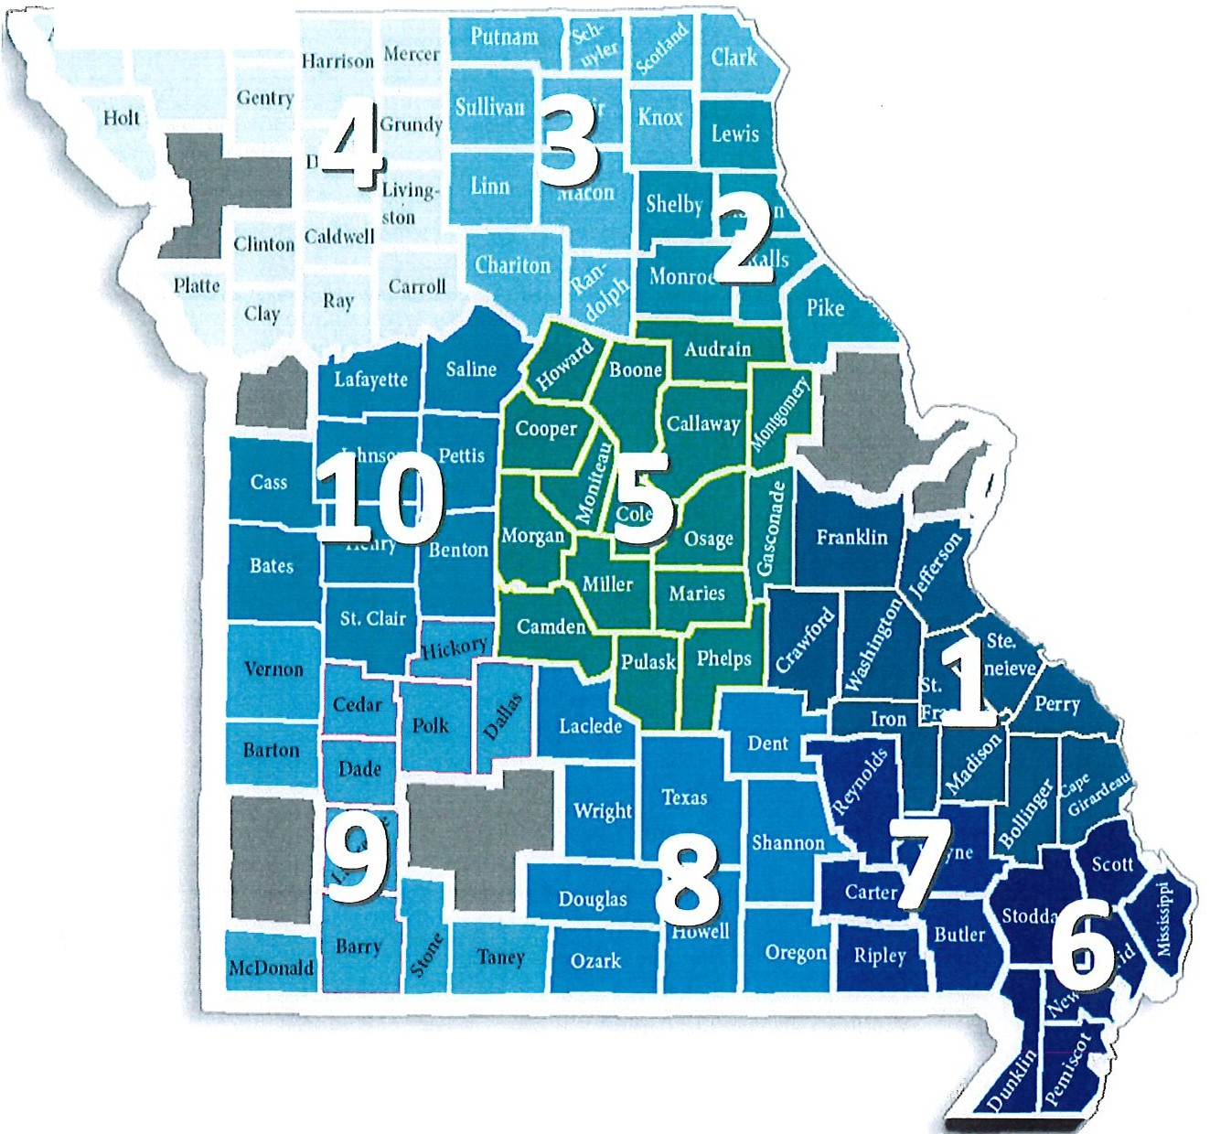

i\1, hb on Nud.a1.1oi Worlh

**Attachment 3: MO Bos CoC Planning Grant Budget**

Project: M0-606 CoC Planning Application

Administration Activities: 100%

The Collaborative Applicant will pay the financial obligations of the CoC, administer subcontracts for work authorized by the MO BoS CoC Board of Directors, and produce financial reports as required or requested by the MO BoS CoC Board of Directors.

The amount of administration is 10% of the planning grant dollars received for MO-606 Continuum of Care. The grant amount for FY23 is $399,500. The FY24 amount is $480,933. The planning grant year is January 1 through December 31. FY23 is the current operating year of the grant for 2025.

The Collaborative Applicant is expected to have personnel attend the monthly board meeting to provide financial reports and answer any questions. During contract discussions, the Collaborative Applicant is required to have personnel in attendance with board members during these discussions.

Administrative time should be built into the budget for a minimum of 4 subcontracts a year, subcontracts with 3 independent contractors performing lead agency duties, monthly payment of bills, a minimum of quarterly drawdowns from HUD’s financial accounting system, and monthly board meetings to present financials and answer questions.